***NAME : Himanshu Dixit***

***ENROLL NO. : B64178***

***BATCH : B10***

***Software Development Fundamentals – I(15B11CI111)***

***ODD 2021***

***Tutorial Sheet – 12***

***Q1.*** *Write a program in C to create and store information in a text file.*

***Solution :***

#include <stdio.h>

#include <stdlib.h>

int main()

{

char str[100];

FILE *fp;

printf("Create a file (test.text) and input text :\n");

fp=fopen("test.text","w");

if(fp==NULL)

{

printf(" Error in opening file!");

exit(1);

}

printf("Input a sentence for the file : ");

gets(str);

fprintf(fp,"%s",str);

fclose(fp);

printf("\nThe file test.text created successfully...!!\n");

return 0;

}

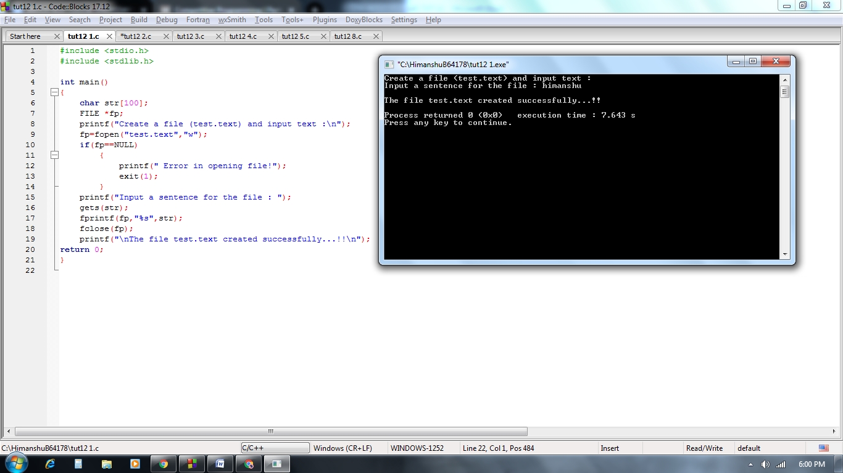

***Q2.*** *Write a program in C to write multiple lines in a text file.****Test Data :*** *Input the number of lines to be written : 3  
The lines are   
I am at JIIT.  
Enrolled in SDF1.*

*I am in Noida.*

***Expected Output :***

*The content of the file test.txt is  :*

*I am at JIIT.  
Enrolled in SDF1.*

*I am in Noida.*

***Solution :***

#include <stdio.h>

#include <stdlib.h>

int main()

{

char str[100],ch;

int n;

FILE *fp;

printf("Enter no. of lines : \n");

scanf("%d",&n);

fflush(stdin);

fp=fopen("test.text","w");

if(fp==NULL)

{

printf(" Error in opening file!");

exit(1);

}

printf("Enter the lines : \n");

for(int i=0;i<n;i++){

gets(str);

fprintf(fp,"%s\n",str);

}

fclose(fp);

printf("\nThe file test.text created successfully...!!\n\n\n");

fp=fopen("test.text","r");

if(fp==NULL)

{

printf(" Error in opening file!");

exit(1);

}

printf("The content of the file test.txt is : \n");

ch=fgetc(fp);

while(ch != EOF){

printf("%c",ch);

ch=fgetc(fp);

}

fclose(fp);

return 0;

}

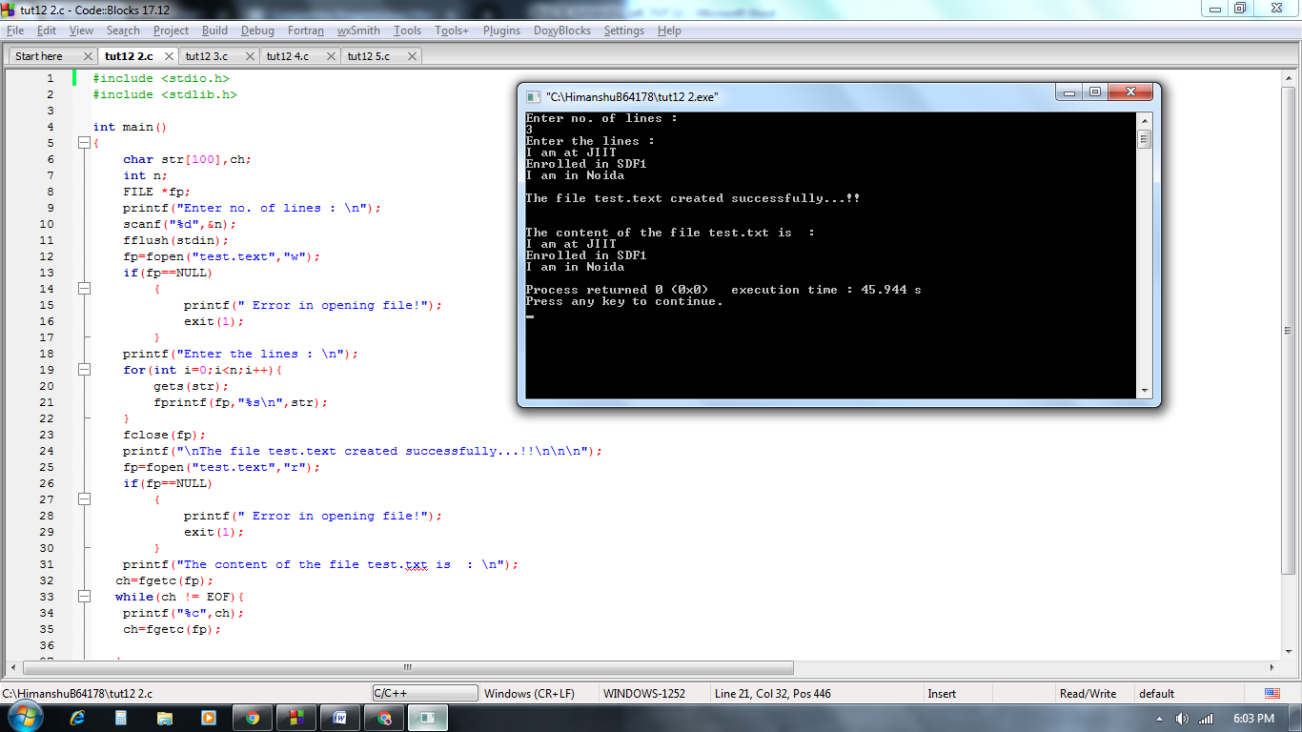

*.*

***Q3.*** *Write a program in C to count a number of words and characters in a file.*

***Solution :***

#include <stdio.h>

#include <stdlib.h>

void main()

{

FILE *fptr;

char ch;

int wrd=1,charctr=1;

printf("Count the number of words and characters in a file :\n");

fptr=fopen("test.text","r");

if(fptr==NULL){

printf("File does not exist or can not be opened.");

exit(1);

}

ch=fgetc(fptr);

printf("The content of the file test.text are :\n");

while(ch!=EOF){

printf("%c",ch);

if(ch==' '||ch=='\n'){

wrd++;

}

else{

charctr++;

}

ch=fgetc(fptr);

}

printf("\nThe number of words in the file test.text are : %d\n",wrd-1);

printf("The number of characters in the file test.text are :%d\n\n",charctr-1);

fclose(fptr);

}

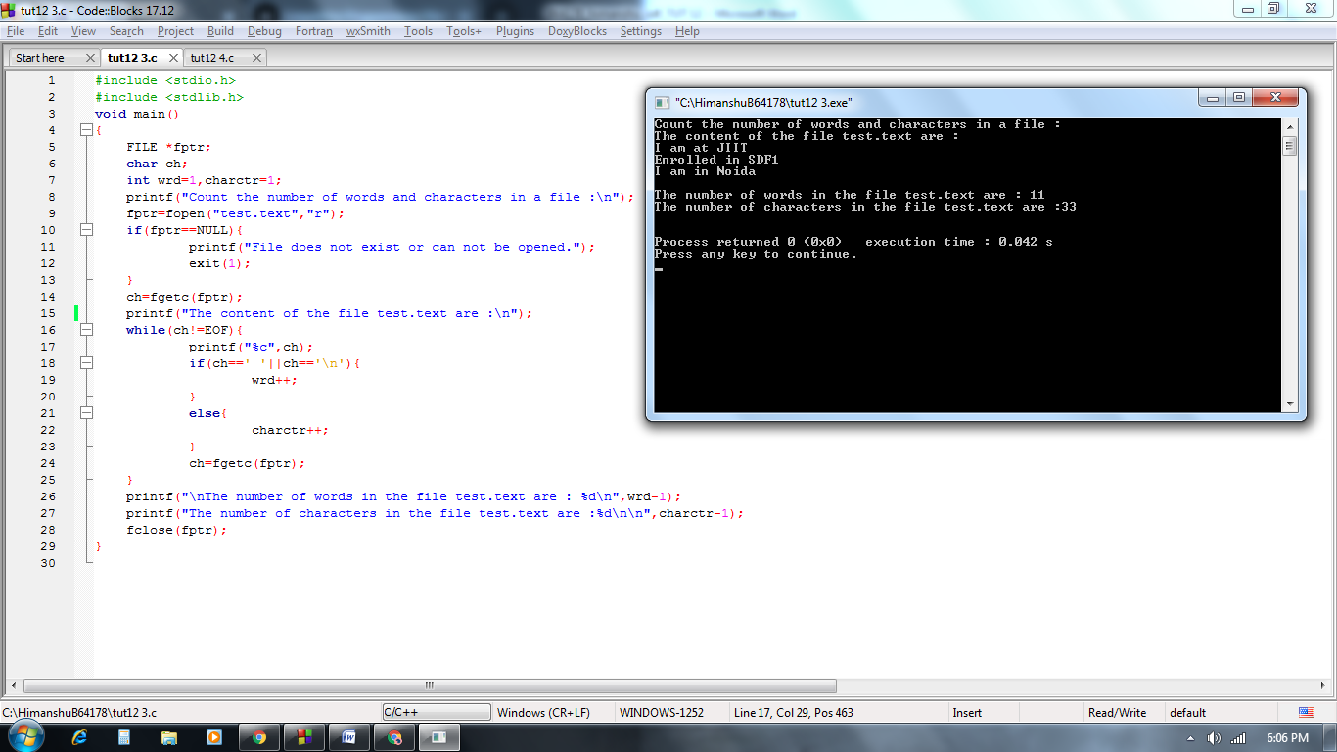

***Q4.*** *Write a program in C to merge two files and write it in a new file.*

***Solution :***

#include <stdio.h>

#include <stdlib.h>

void main()

{

FILE *f1, *f2, *f;

char ch, fname1[20], fname2[20], fname3[30];

printf(" Merge two files and write it in a new file :\n");

printf(" Input the 1st file name : ");

scanf("%s",fname1);

printf(" Input the 2nd file name : ");

scanf("%s",fname2);

printf(" Input the new file name where to merge the above two files : ");

scanf("%s",fname3);

f1=fopen(fname1, "r");

f2=fopen(fname2, "r");

if(f1==NULL || f2==NULL)

{

// perror("Error Message ");

printf(" File does not exist or error in opening...!!\n");

exit(EXIT_FAILURE); //exit(1);

}

f=fopen(fname3, "w");

if(f==NULL){

// perror("Error Message ");

printf(" File does not exist or error in opening...!!\n");

exit(EXIT_FAILURE);

}

while((ch=fgetc(f1))!=EOF)

{

fputc(ch, f);

}

fputc('\n', f);

while((ch=fgetc(f2))!=EOF)

{

fputc(ch, f);

}

printf(" The two files merged into %s file successfully..!!\n\n", fname3);

fclose(f1);

fclose(f2);

fclose(f);

}

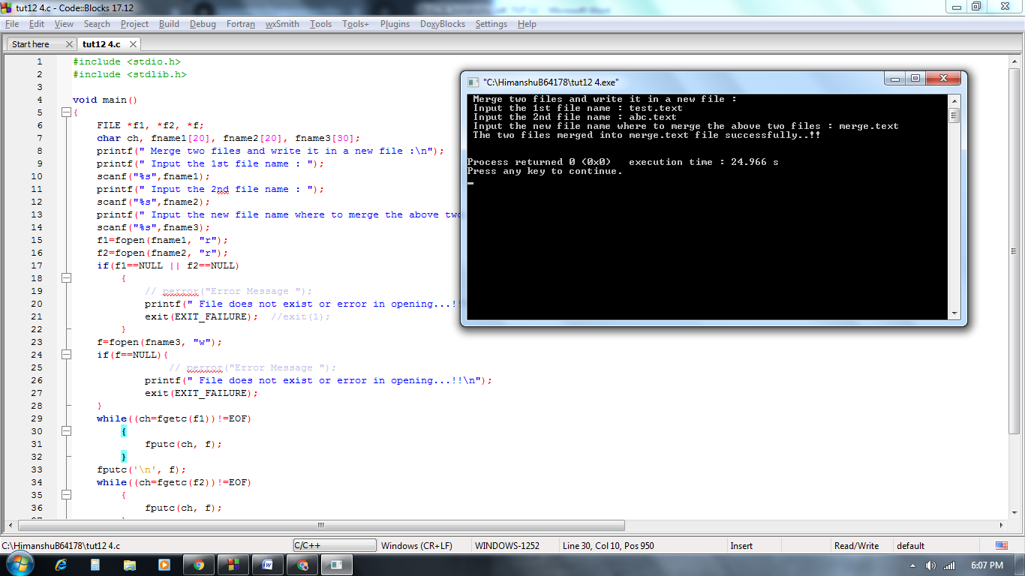

***Q5.*** *Convert All Characters in Upper Case of a File using C Program*

***Solution :***

#include <stdio.h>

#include <stdlib.h>

#include <ctype.h>

int main(){

FILE *fp,*fp1;

char ch;

fp=fopen("test.text","r");

if(fp==NULL){

printf("Error in opening file.\n");

exit(1);

}

fp1=fopen("temp.txt","w");

if(fp1==NULL){

printf("Error in creating temp file.\n");

exit(1);

}

while((ch=fgetc(fp))!=EOF){

if(islower(ch)){

ch=toupper(ch); //ch-32

}

putc(ch,fp1);

}

fclose(fp);

fclose(fp1);

fp=fopen("temp.txt","r");

if(fp==NULL){

printf("Error in opening file.\n");

exit(1);

}

printf("Content of file\n");

while((ch=getc(fp))!=EOF){

printf("%c",ch);

}

printf("\n");

fclose(fp);

return 0;

}

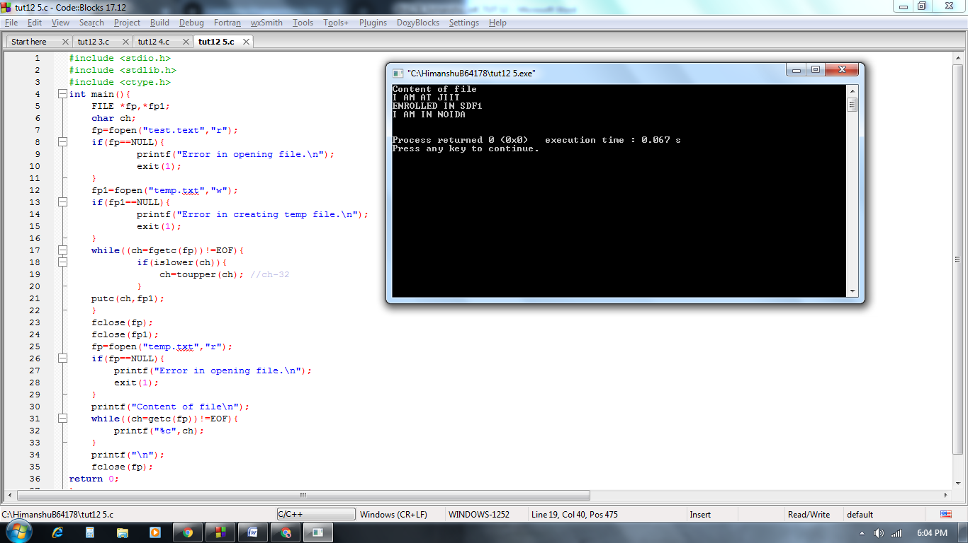

***Q6.*** *Write a program to print reverse content of file. [using command line arguments].*

*Actual file contents:  
This is line1.  
This is line2.  
This is line3.  
This is line4.  
This is line5.  
This is line6.*

*Output:*

Terminal command: ./prg2 file1.txt

.6enil si sihT

.5enil si sihT

.4enil si sihT

.3enil si sihT

.2enil si sihT

.1enil si sihT

***Solution :***

#include <stdio.h>

#include <string.h>

int main(int argc, char *argv[])

{

FILE *fp1;

int cnt = 0;

int i = 0;

if( argc < 2 )

{

printf("Insufficient Arguments!!!\n");

printf("Please use \"program-name file-name\"format.\n");

return -1;

}

fp1 = fopen(argv[1],"r");

if( fp1 == NULL )

{

printf("\n%s File can not be opened : \n",argv[1]);

return -1;

}

//moves the file pointer to the end.

fseek(fp1,0,SEEK_END);

//get the position of file pointer.

cnt = ftell(fp1);

while( i<=cnt )

{

i++;

fseek(fp1,-i,SEEK_END);

printf("%c",fgetc(fp1));

}

fclose(fp1);

return 0;

}

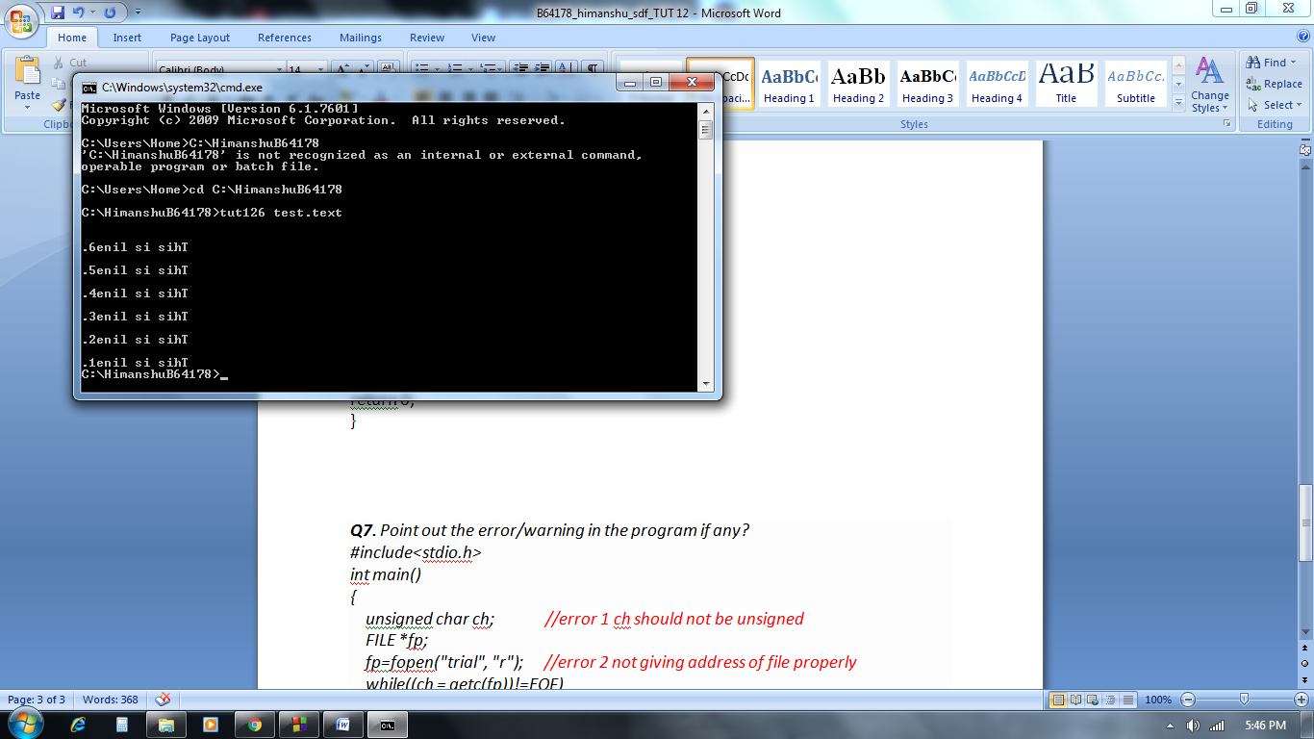

***Q7.*** *Point out the error/warning in the program if any?*

*#include<stdio.h>*

*int main()*

*{*

*unsigned char ch; //error 1 ch should not be unsigned*

*FILE *fp;*

*fp=fopen("trial", "r"); //error 2 not giving address of file properly*

*while((ch = getc(fp))!=EOF)*

*printf("%c", ch);*

*fclose(fp);*

*return 0;*

*}*

***Solution :***

***Q8.*** *Write to a binary file using fwrite() using following structure:*

*struct threeNum {    int n1, n2, n3; };.*

***Solution :***

#include <stdio.h>

#include <stdlib.h>

struct threeNum{

int n1, n2, n3;

};

int main()

{

int n;

struct threeNum num;

FILE *fptr;

fptr = fopen("program.bin","wb");

if(fptr==NULL)

{

printf("cannot open file");

exit(1);

}

for(n=1;n<5;n++)

{

num.n1=n;

num.n2=5*n;

num.n3=5*n+1;

fwrite(&num, sizeof(num), 1, fptr);

}

fclose(fptr);

fptr = fopen("program.bin","rb");

if(fptr==NULL)

{

printf("cannot open file");

exit(1);

}

for(n=1;n<5;n++)

{

fread(&num, sizeof(num), 1, fptr);

printf("n1=%d\nn2=%d\nn3=%d\n\n",num.n1,num.n2,num.n3);

}

fclose(fptr);

return 0;

}

